Unmanaged PoE Switch

🔌 What is an Unmanaged PoE Switch?
# Source: Chatgpt (GPT‑5 Mini) at [12/18/2025]
An Unmanaged PoE Switch is a plug-and-play network switch that can deliver both power and data to connected devices — without any configuration required. It’s a combination of:
- ✅ Unmanaged switch (no setup or management interface)
- ✅ PoE (Power over Ethernet) support (power + data over one Ethernet cable)
This type of switch is ideal for simple networks where you want to power devices like IP cameras, VoIP phones, or wireless access points without running separate power lines.

⚙️ Key Features
# Source: Chatgpt (GPT‑5 Mini) at [12/18/2025]
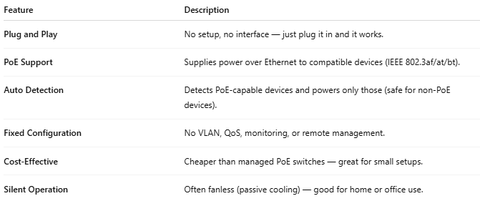

Feature | Description
Plug and Play | No setup, no interface — just plug it in and it works.
PoE Support | Supplies power over Ethernet to compatible devices (IEEE 802.3af/at/bt).
Auto Detection | Detects PoE-capable devices and powers only those (safe for non-PoE devices).
Fixed Configuration | No VLAN, QoS, monitoring, or remote management.
Cost-Effective | Cheaper than managed PoE switches — great for small setups.
Silent Operation | Often fanless (passive cooling) — good for home or office use.

🏠 Example Use Case
# Source: Chatgpt (GPT‑5 Mini) at [12/18/2025]

Small Office IP Camera Setup
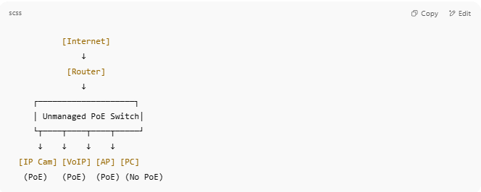
[Internet]
↓
[Router]
↓
┌────────────────────┐
│ Unmanaged PoE Switch│
└┬────┬────┬────┬─────┘
↓ ↓ ↓ ↓
[IP Cam] [VoIP] [AP] [PC]
(PoE) (PoE) (PoE) (No PoE)

- All devices get data.
- PoE devices also get power via the same Ethernet cable.
- No setup required.

🆚 Unmanaged PoE Switch vs Managed PoE Switch
# Source: Chatgpt (GPT‑5 Mini) at [12/18/2025]
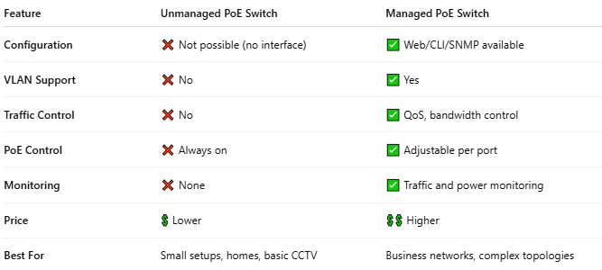

Feature | Unmanaged PoE Switch | Managed PoE Switch
Configuration | ❌ Not possible (no interface) | ✅ Web/CLI/SNMP available
VLAN Support | ❌ No | ✅ Yes
Traffic Control | ❌ No | ✅ QoS, bandwidth control
PoE Control | ❌ Always on | ✅ Adjustable per port
Monitoring | ❌ None | ✅ Traffic and power monitoring
Price | 💲 Lower | 💲💲 Higher
Best For | Small setups, homes, basic CCTV | Business networks, complex topologies

🔌 Standards Supported
# Source: Chatgpt (GPT‑5 Mini) at [12/18/2025]

Most Unmanaged PoE Switches support:
- 802.3af – up to 15.4W per port
- 802.3at (PoE+) – up to 30W per port
(Some may support 802.3bt for 60W or 100W, but that's less common.)

✅ Pros
# Source: Chatgpt (GPT‑5 Mini) at [12/18/2025]
- Simple and fast to deploy
- Ideal for non-technical users
- Powers devices directly
- Lower cost

❌ Cons
# Source: Chatgpt (GPT‑5 Mini) at [12/18/2025]
- No customization or control
- Can’t isolate traffic (no VLANs)
- Limited monitoring or troubleshooting options

